***JAYPEE INSTITUTE OF INFORMATION***

***TECHNOLOGY, NOIDA , SECTOR-62***



***PROJECT REPORT***

***ECONOMICS (15B11HS211)***

***Market Structure***

***SUBMITTED TO :***

***Mrs. KANUPRIYA MISRA BAKHRU ma’am***

***Mr. MANAS RANJAN BEHERA sir***

***BY :***

***TEAM MEMBERS (B11 BATCH):***

* ***HIMANSHU DIXIT (21103262)***
* ***SRISHTI GARG (21103227)***
* ***RHYTHM SRIVASTAVA (21103234)***
* ***DIVYA (21103233)***
* ***KAMAL GARG (21103231)***

***ACKNOWLEDGEMENT***

*We extend our sincere thanks to* ***Jaypee Institute of Information and Technology*** *which provided us with the opportunity to make the project. The project could have never been possible without the support of various sources and my team. It is extremely impossible to thank every individual who has helped me in completing this project. Some people have helped in the basic formularization and there were sources that helped me in giving the ideas a physical form/ shape. I am extremely grateful to my mentor, Mrs KANUPRIYA MISRA BAKHRU and Mr MANAS RANJAN BEHERA , and my team mates for their support and guidance in the project right from the beginning. My team vital support helped the project to take a logical and suitable shape. We take this opportunity to thank the College authorities, for extending their full support and cooperation in the project.*

*Last but not the least; I would like to thank everyone who has offered a helping hand when required.*

***content***

* ***Acknowledgement…………………….2***
* ***Market Introduction…………………4***
* ***Types of Market……………………….5***
* ***Perfect Competition…………………7***
* ***Monopoly……………………………….10***
* ***Monopolistic Competition……….13***
* ***Oligopoly………………………………..16***
* ***Summary………………………………..19***
* ***References……………………………..20***



***Introduction***



**MARKET**

*Definition: A market is defined as the sum total of all the buyers and sellers in the area or region under consideration. The area may be the earth, or countries, regions, states, or cities.*

*Market is a place where buyers and sellers are exchanging goods and services with the following considerations such as:*

* *Types of goods and services being traded*
* *The number and size of buyers and sellers in the market*
* *The degree to which information can flow freely*

*Market structure refers to the way that various industries are classified and differentiated in accordance with their degree and nature of competition for products and services.*

*This report will cover the types of market such as perfect competition, monopoly, oligopoly and monopolistic competition, in which business firms operate.*

***Types of market***

*Market is classified into two types.*

* 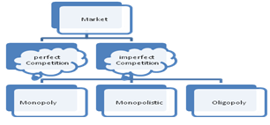*PERFECT MARKET*
  + - *Perfect Competition.*
* *IMPERFECT MARKET*
  + - *Monopoly.*
    - *Oligopoly.*
    - *Monopolistic competition.*

***1) PERFECT MARKET***

*A market situation which consists of a very large number of buyers and sellers offering a homogeneous product. Under such condition, no firm can affect the market price. Price is determined through the market demand and supply of the particular product, since no single buyer or seller has any control over the price.*

***2) IMPERFECT MARKET***

*In economic theory, imperfect competition is a type of market structure showing some but not all features of competitive markets*

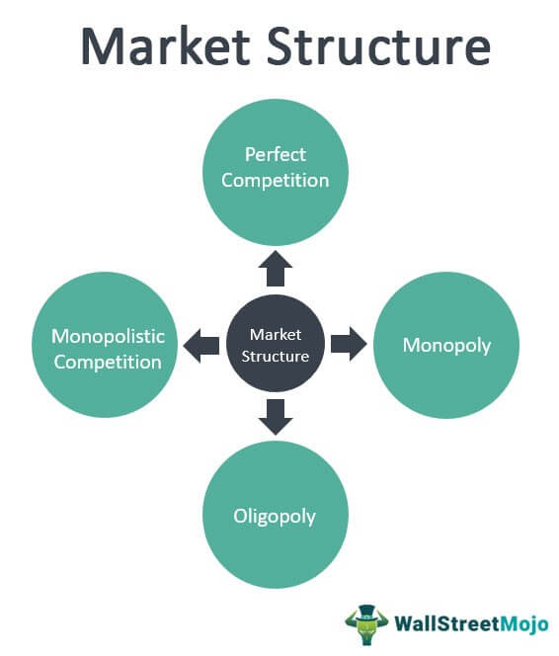

***Perfect competition***

Perfect Competition cannot be found in the real world. For such to exist, the following conditions must be observed and required:

* A large number of sellers Selling a homogenous product
* No artificial restrictions placed upon price or quantity
* Easy entry and exit . All buyers and sellers have perfect knowledge of market conditions and of any changes that occur in the market
* Firms are “price takers”.

Examples :-

* Agricultural products
* Financial instruments
* Commodities

**Characteristics of a perfect competitive market :**

* There are very many small firms.
* All producers of a good sell the same product.
* There are no barriers to enter the market.
* All consumers and producers have ‘perfect information’.
* Firms sell all they produce, but they cannot set a price.

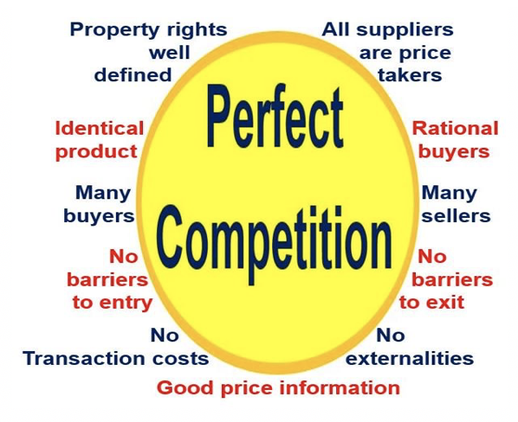

**Short Run Analysis :**

* The firm’s objective is to produce the level of output that will maximize profit.
* Some inputs are variable and therefore fixed costs
* arise regardless whether the firm is operating or
* not.
* Since the firm is a price taker, it has no control on
* the price of a product .

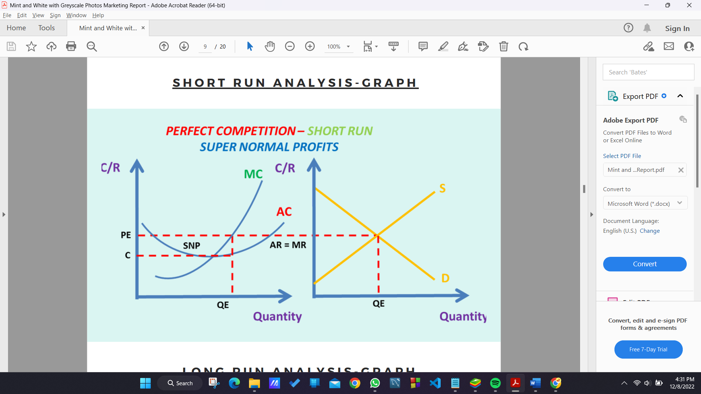

**Long Run Analysis :**

* All inputs and costs of production are variable .
* The firm can build most appropriate scale of plant to produce the optimum level of output .

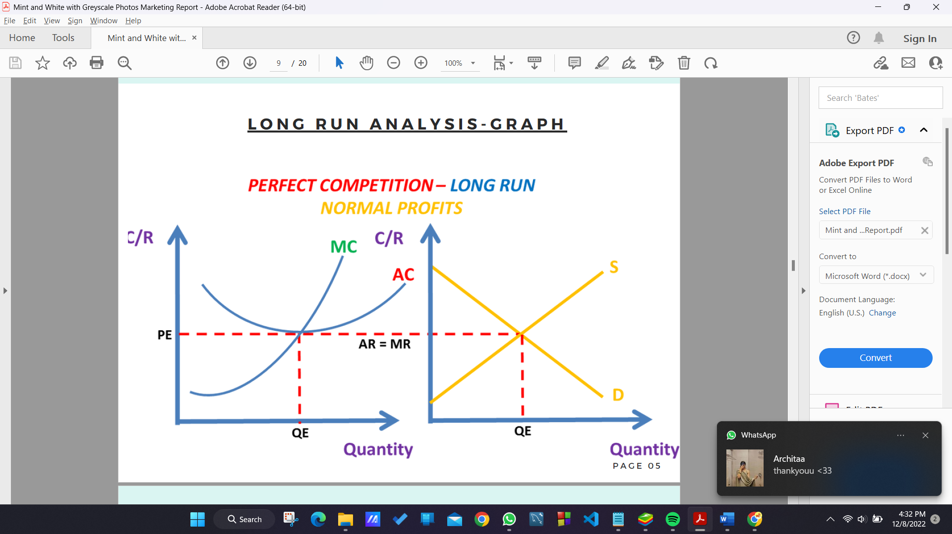

***Monopoly***

Monopoly comes from a Greek word ‘monos’ which means ‘one’ and ‘polein’ means

to ‘sell’.

**There is only one seller of goods or** **services.**

A monopoly should be distinguished from a cartel.

*(Cartel refers to a market situation in which firms agree to cooperate with one another to behave as if they were a single firm and thus eliminate competitive behavior among them).*

Examples :-

* Pharmaceuticals with patents
* regulated utilities (although this is changing)
* last chance gas station on the edge of the desert

**Sources of Monopoly :-**

There is only one producer or seller of goods and only one provider of services in the market.

* New firms find extreme difficulty in entering the market. The existing monopolist is considered
* giant in its field or industry.
* There are no available substitute goods or services so that it is considered unique.
* It controls the total supply of raw materials in the industry and has no control over price.
* It owns a patent or copyright.
* Its operations are under economies of scale.

**Short Run Analysis :**

A monopolist is considered a price maker, since he is the sole seller of a product that has no close substitute in the market

**Long Run Analysis :**

In the long-run, all inputs and costs are variable, and the monopolist can make his optimal scale of plant to make the best level of output.

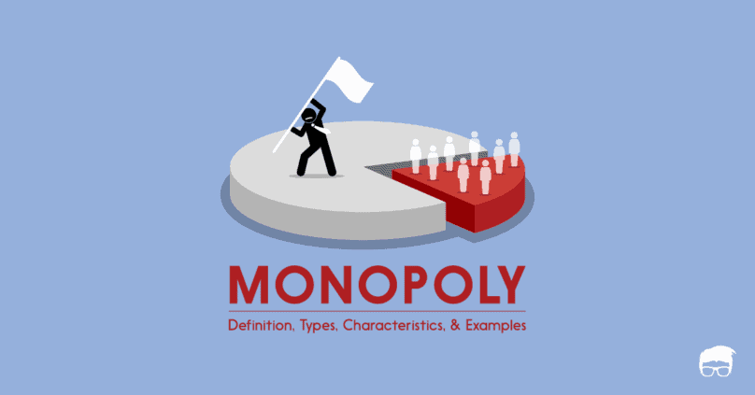

**Classification of Monopoly :**

Monopolies are classified according to circumstances they arise from, that is, cost structure of the industry, possibly the result of law, or by other means.

**Natural Monopoly** : is a market situation where is a single firm can supply the entire market due to the fundamental cost structure of the industry.

**Legal Monopoly** : is sometimes called as de jure monopoly, a form of monopoly which the government grants to a private individual or firm over the product or services.

**Coercive Monopoly** : is a form of monopoly whose existence as the sole producer and distributor of goods and services is by means of coercion (legal or illegal), so that most of the time it violates the principle of free market just to avoid competition.

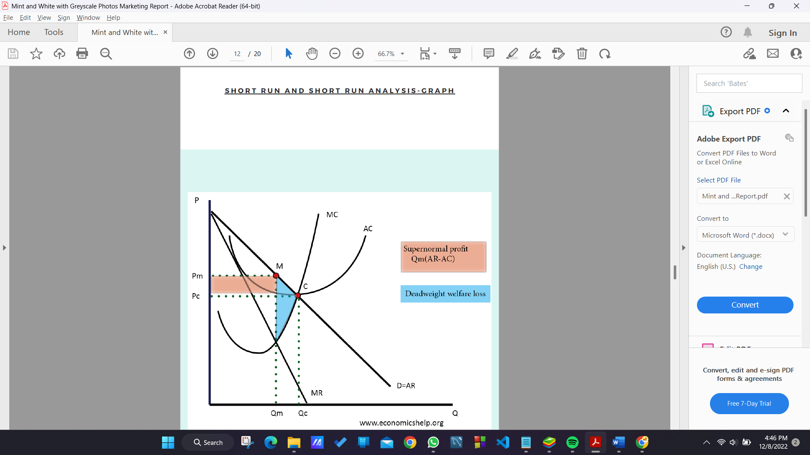

***Monopolistic competition***

Market situation in which there are many sellers producing highly differentiated products.

Monopolistic competition is also perfect competition plus product

differentiation.

Examples :-

* boutiques
* restaurants
* repair shops

Product differentiation gives each monopolistic competitor some

market power, since each competitor can raise price slightly without losing all its customers.

A large number of buyers and sellers in a given market act independently.

* There is a limited control of price because of product differentiation.
* Sellers offer differentiated products or similar but not identical products.
* New firms can enter the market easily. However, there is
* a greater competition in the sense that new firms have to offer better features of their products.
* Economic rivalry centers not only upon price but also upon product variation and product promotion.

**MONOPSONY**

*A market situation in which there is only one buyer of goods and services in the market. It is sometimes considered analogous to monopoly in which there is only one seller of goods and services*

*in the market.*

*Monopsony power gives them the ability to control their unit cost for an input which is similar to the way the monopoly controls their price.*

**OLIGOPSONY**

*A market situation where there are a small**number of buyers. This is usually with a small**number of firms competing to obtain the factors**of production.*

*Under this market situation, firms are buyers and not sellers. This is sometimes analogous to oligopoly, where there are few sellers.*

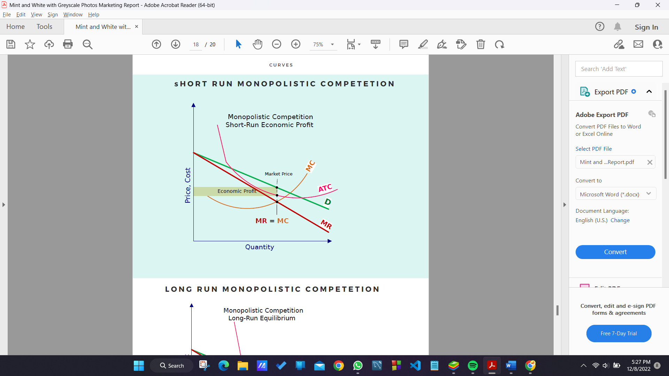

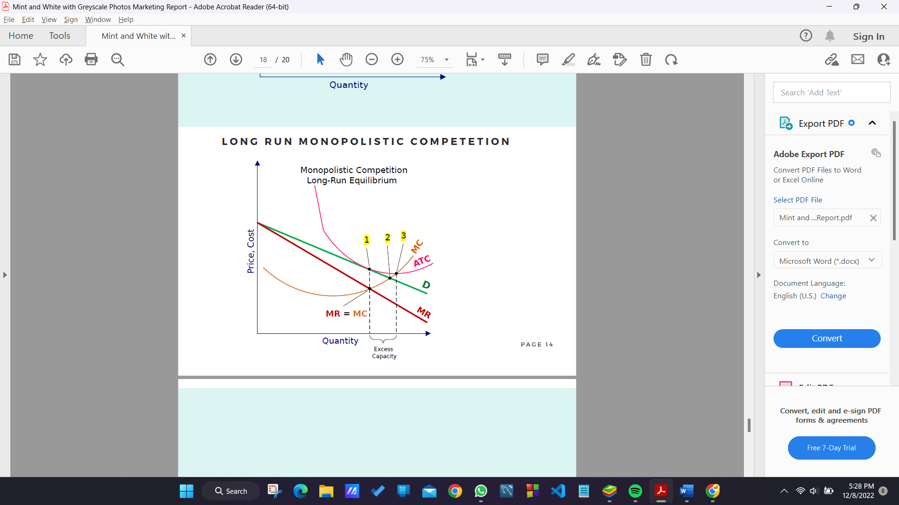

***Oligopoly market***

Oligopoly comes from the Greek word “*oligo*” which means ‘few’ and “*polein*” means ‘to sell’.

**small number of sellers, each aware of the action of others.**

* All decisions depend on how the firms behave in relation to each other.
* In oligopoly, conjectural interdependence is present, that is, the decision of one firm influences and are influenced by the decision of other firms in the market.

In oligopoly, conjectural interdependence is present, that is, the decision of one firm influence and are influenced by the decision of other firms in the market.

Examples :-

* oil refining
* processed foods
* airlines
* internet access and cell phone service

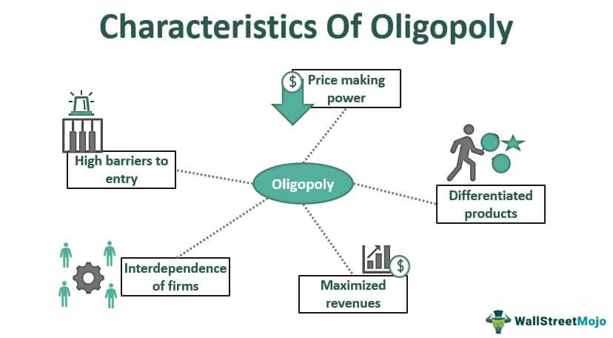

**Characteristics :**

There are a small number of firms in the market selling differentiated or identical products.

* The firm has control over price because of the small number of firms providing the entire supply of a certain product.
* There is an extreme difficulty for new competitors to enter the market.

**Types of Oligoply :**

**1.** **Pure or Perfect Oligopoly**

If the firms produce homogeneous products.

**2.** **Imperfect or Differentiated Oligopoly**

If the firms produce differentiated products.

**3.** **Collusive Oligopoly**

If the firms cooperate with each other in determining Price or output or both.

**4.** **Non - collusive Oligopoly**

If firms in an oligopoly market compete with each other.

**Types of Organization of Monopoly :**

**Cartel** is a formal agreement among oligopolists to set - up a monopoly price, allocate output, and share profit among members.

**Collusion** is a formal or an in formal agreement among oligopolists to adopt policies that will restrict or reduce the level of competition in the market.

**Analyzing Oligopoly using kinked demand curve :**

Kinked demand curve is defined as the demand curve of the individual firm in oligopolistic market. It has a “kink” at the existing price caused by the firm’s expectation of the actions its rivals are likely to take if the firm changes its price.



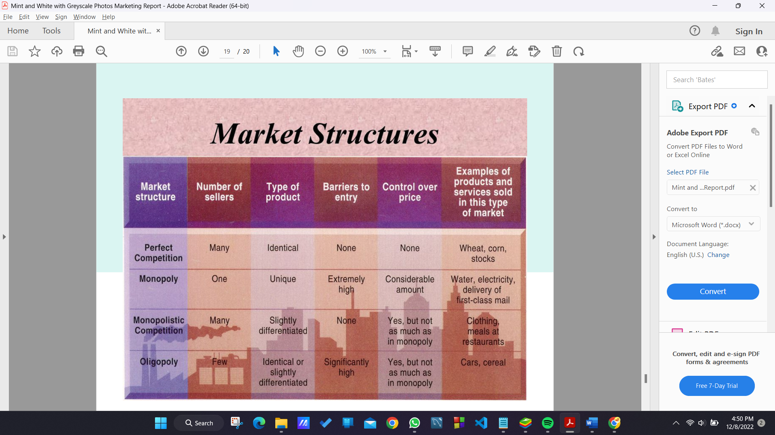

***References***

***1.*** *Salvatore,D., Managerial Economics in a Global Economy, 8th ed., Thomson Asia, 2015.*

***2.*** *Keat, P., Young, P., & Erfle, S., Managerial economics: Economic tools for today’s decision makers (7th ed.) Upper Saddle River, NJ: Prentice Hall,2014*

***3.*** *https://en.wikipedia.org/wiki/Market_structure.*

***4.*** *https://prezi.com/ewepujou9xam/market-structure-project/*

